

AUGUST 2017 EXAMINATION

School of InfoComm Technology
(Diploma in Information Security & Forensics)

Level 2 Time Allowed: 2 Hours

INFORMATION SECURITY

(009254)

INSTRUCTIONS TO CANDIDATES:

1. Check carefully to ensure you are sitting for the correct paper.

2. There are FIVE questions. Answer ALL questions.

3. All questions carry equal marks.

4. Begin each question on a separate page.

5. This paper consists of 8 pages including this cover page. Check carefully to make sure your set is complete.

There are FIVE questions. Answer ALL questions.

QUESTION 1 (20 marks)

- ABC Bank incorporates a mandatory vacation policy for all its employees.
  - Briefly describe the measures taken by the bank when the employee is on mandatory vacation.
  - Explain why it is important for the bank to implement this policy.
  - Identify the type of security control implemented by the bank.
1a(i). Discourages people from doing fraudulent activities as they have a high chance that they might be caught.
(ii). Prevent fraud.
(iii). Detective/administrative control.
(5 marks)

- Employees at ABC Bank are required to swipe their employee pass to gain access to different rooms in the bank.
  - Identify the type of authentication the bank has implemented to enable employees to gain access to rooms in the bank.
  - Identify ONE vulnerability with this type of authentication.
  - Suggest TWO additional preventive controls that the bank can implement to improve its room access security. For each control suggested, explain clearly the type of control and how it improves the security.
1b(i). Authentication through the use of tokens
1b (ii).Prone to RFID stealing
1b (iii). Use authentication with a password to ensure 2FA has been fulfilled and also to implement the use of physical security by hiring security guards.

1b(i). Something you have
(ii). The card might be lost
(iii). Implement something you know or something you are, such as password and biometric
(8 marks)

- The bank conducts a nightly backup of its data. The backups are kept in the backup cabinet in the data center.
  - Which principle of the CIA (Confidentiality, Integrity and Availability) triad is addressed by performing these backups?
  - What can be done by the bank to improve their backup process so that the other two principles of the CIA triad are addressed?
  - The bank has designated 2 staff to perform the backup and 2 other staff to perform any restoration of data from the backups. Explain why the bank makes such an arrangement.
c(i). Hash the backup and encrypt it with the data and save it somewhere else, and encrypt and backup everything
(ii).

(7 marks)

QUESTION 2 (20 marks)

(a) Using Columnar Transposition in Symmetric Cryptography, decrypt the following ciphertext using the key: “NGEEANN”:

phraypcr*gtyo*

Note that the number of columns in Columnar Transposition are of the same size as the key for this case.
(6 marks)

(b) Ally and Billy are holding a pair of keys for use with the RSA cryptosystem.

Ally’s Public and Private keys: A_{pub} and A_{pri}
Billy’s Public and Private keys: B_{pub} and B_{pri}

- Ally wants to send Billy a lengthy document. With the aid of a well-labelled diagram, explain how Billy can be assured that the document comes from Ally. You may assume that they are NOT concerned with the confidentiality of the document. Your explanation should be based on the concept of digital signature and should clearly identify the keys used in each step of the transmission from Ally and Billy.
(8 marks)
(ii) If confidentiality is required for the transmission of the document, explain how this security principle can be achieved by suggesting the additional steps to your answer in 2(b)(i).
Ans: Encrypt the data
(2 marks)

(c) A bank customer has a chip-based ATM card with a personal identification number (PIN). Assume that the hash of the PIN is stored in the card. When visiting an ATM machine, the customer is asked to insert the card and then enter a PIN on the keypad. Explain how does the issuer of the ATM bank verify the card in use?
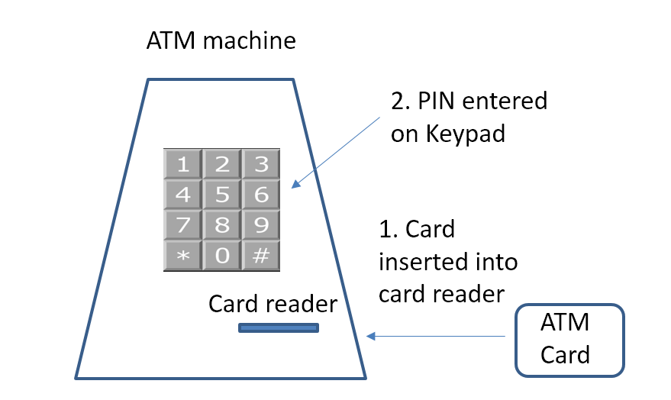
Figure 2(c): ATM machine
(4 marks)
Ans: Bank check for something the user has by asking them to insert atm card, and ask them for the password and hash and compare with their database
QUESTION 3 (20 marks)

The logical network diagram for ISF Pte Ltd is shown in Figure 3. Answer the following questions based on this network diagram.

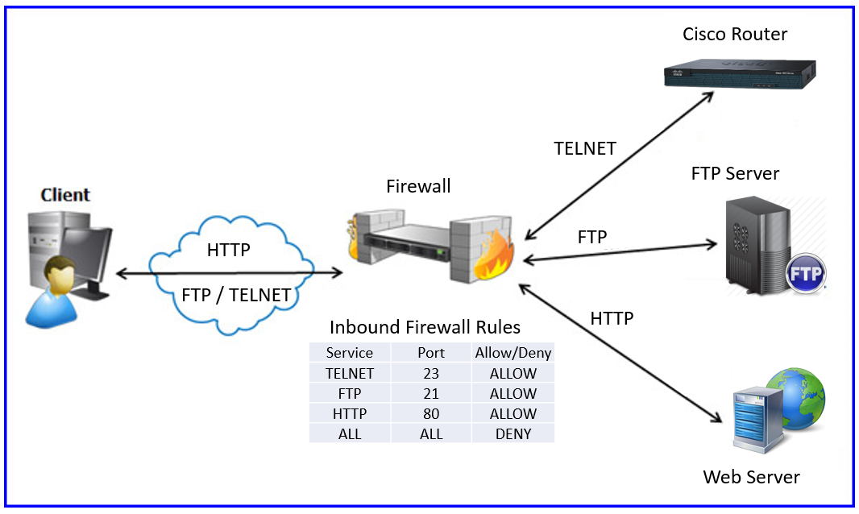
Figure 3: Logical Network Diagram for ISF Pte Ltd

- Explain why the three protocols used to access the Cisco router, FTP Server and Web Server are not appropriate from a security point of view. Suggest ONE secure alternative for each of these protocols.
Ans:
HTTP: HTTPS
FTP: FTPS
Telnet: SSH
All these send in plaintext and not secured.
(4 marks)

(b) Based on the alternative protocols you have suggested in 3(a), modify the inbound firewall rules in Figure 3 to enable communication between Client and the Cisco Router/FTP Server/Web Server.

Service | Port | Allow/Deny
SSH | 22
HTTPS | 443 | allow
FTPS
Table 3(b): Modified Inbound Firewall Rules

Reproduce Table 3(b) in your answer booklet.
(7 marks)
- Assume that the servers of ISF Pte Ltd are unable to adopt the secure protocols which you have suggested in 3(b). Recommend another method to implement secure access by users to their servers from the internet that does not require the servers to be modified. What network protocol would be used by the method recommended?
Ans: VPN
(4 marks)

- The last rule in the firewall is (ALL, ALL, DENY). This is a common security best practice. Identify the name of this best practice.
Ans: Implicit deny
(1 mark)

(e) Abnormal log entries on the Web Server as shown in Figure 3(a) were found during a routine security check. Explain the cause of the abnormal log entries. Suggest what the company can do to proactively detect such abnormal network behavior.

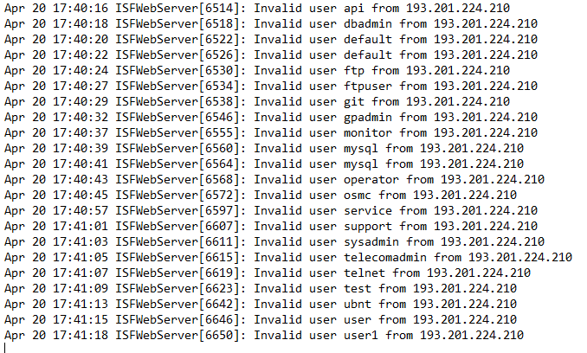
Figure 3(e): Log Entries on Web Server
Answer: DoS bruteforce

(4 marks)
QUESTION 4 (20 marks)

The two common Public Key Infrastructure (PKI) trust models, the Hierarchical Trust Model and Distributed Trust Model, are shown in Figure 4-1 and Figure 4-2 respectively. PKI involves Certificate Authority (CA) and Digital Certificates. The trust model refers to the type of trusting relationship that can exist between the individuals and the entities.

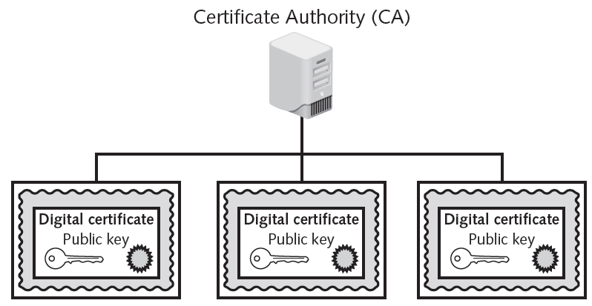

Figure 4-1: Hierarchical Trust Model

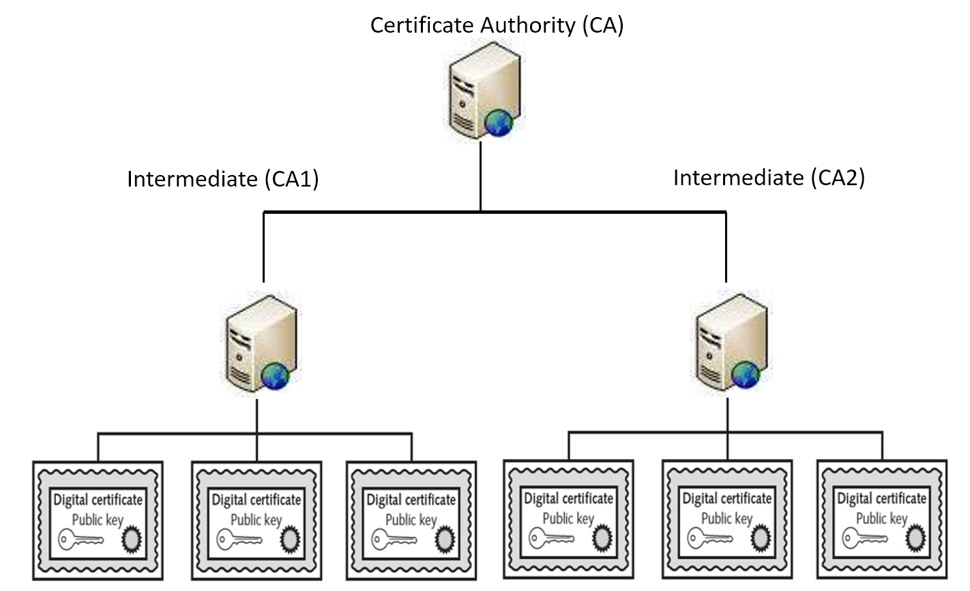

Figure 4-2: Distributed Trust Model

- Identify and discuss the characteristics/limitations of each of the two models by making references to the terms Certificate Authority and Digital Certificates.
1st diagram: Easy to set up but fails easily if that CA fails
(8 marks)

- Suggest ONE suitable application for each of the trust models.
(4 marks)

- Discuss TWO major risks associated with the PKI implementation.

Ans: Intermediate Cas shut down → only a certain number of certificates affected

(8 marks)
QUESTION 5 (20 marks)

- The project timeline for FinTek Pte Ltd is shown in Figure 5(a).

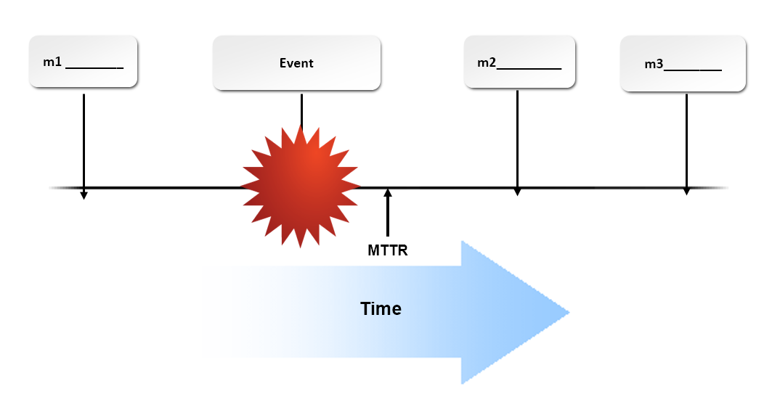

Figure 5(a): Logical Network Design for FinTek Pte Ltd

(i) Figure 5(a) shows critical milestones, denoted by m1, m2 and m3, that must be defined in a Disaster Recovery Plan. Identify the THREE milestones and explain clearly the meaning of each milestone.
(6 marks)

(ii) Explain what is meant by Mean Time to Recovery (MTTR) and its significance in the Disaster Recovery Plan.
(4 marks)

(b) You have recently taken over the network administrator position in a trading company. After understanding the operations of the department and the IT system, you realised that the department has higher management support, a healthy budget and a very good team of security experts.

However, it does not have a good Intrusion Detection System for the network. The trading depends heavily on the network and any problem will be highly damaging to the business. As a first-cut assessment, would a system using a statistical anomaly detection or rule-based detection approach be suitable? Give TWO reasons for your choice.

Ans: Rule based IDS as behavior based IDS needs time to initialize and the system is critical to the company.

(4 marks)

(c) The following is an alert report cited at a security website:

“A potentially dangerous Internet attack on personal computers by a virus designed to steal financial data and passwords from Web users rippled across the Internet on Friday”, a computer security expert said.

“All of these took place when you clicked on one of the links while viewing the web page”, the expert said. “You don't even know that parts of your browser have been redirected to another website.”

Based on the above report:

- Identify and describe the attack technique.
Ans: The attack technique is phishing. The user would be tricked to click on a link that might not seem malicious to them.
(4 marks)
(ii) Suggest ONE countermeasure for the attack you have identified in 5(c)(i).
Ans: Educate the users.
(2 marks)

** END OF PAPER **

